学术邀请报告
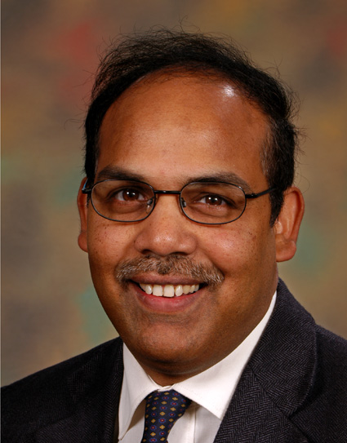
题 目：Microsystems for Life Science and Healthcare
报告人：Professor Ejaz Huq
Rutherford Appleton Laboratory Science and Technology Facilities Council，UK
时 间：2011 年 6月20日(周一) 下午4:00
地 点：五号教学楼502会议室
摘 要：
Progress in micro & nano electromechanical systems, microelectronics, microfabrication and micromachining have enabled the development of a new class of technology, applied to life-sciences, called BioMEMS. The inherent characteristics of BioMEMS promise the production of miniature, smart, and low-cost biomedical devices that could revolutionize biomedical investigation and clinical practice. Such devices and associated micro and nanotechnology are being explored for applications such as biochemical sensors for blood analysis, flow and pressure sensors, immunosensors, surgical instruments, tissue repair, artificial organs, diagnostic tools and drug delivery systems. Advantages include: greater functionality, miniaturisation of the total system, high performance based on parallel processing, high speed based on direct data processing and cost reduction.

报告人简介：

Ejaz Huq is a Council Fellow and Senior Principal Scientist at the UK’s Science and Technology Facilities Council’s [STFC] Rutherford Appleton Laboratory [RAL]. He obtained PhD in Electrical Engineering from Cambridge University in 1989. He was appointed Research Associate at Cambridge University (Materials Science Department) for the following 3 years to work on superconducting tunnel junctions for terahertz mixers. At RAL since 1993 he has worked as Task Leader on various national and international programs including the Joint European Submicron Silicon Initiative [JESSI] and the UK Dept. of Trade and Industries funded Innovation in Industrial Lithography (ISL). He initiated research in field emission at RAL some years ago and has made major contributions in this field including the development of world’s smallest ion trap mass spectrometer which is deployed on the European Space Agency’s Rosetta Mission. He is the recipient of 2 international awards for his work on silicon based field emission.

